Bipolar Disorder Treatment
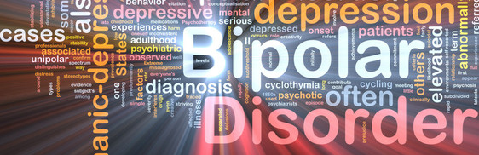
Description
Bipolar Disorder is a Mood Disorder, characterized by experiencing intense mood shifts, which usually cycle between extreme highs and extreme lows. The changing moods often also cause other changes in ones’ life and energy levels and over time, can often make it difficult for one to live and function healthily. The mood shifts of Bipolar Disorder are much more prominent than mood changes that most people experience and are very unpredictable, which make it hard for people to fend against them. Because of the nature of these mood cycles, it’s important for someone to have professional help in dealing with Bipolar Disorder.
Symptoms
The most prominent symptoms of Bipolar Disorder are the mood fluctuations. The “lows” of these mood fluctuations consist of overwhelming sadness, apathy, and often hopelessness. During these depressive episodes it’s also common to experience extreme fatigue, loss of appetite, irritability, withdrawal from others, and even suicidal thoughts. During the “highs” of the mood shift, which are referred to as “manic episodes,” one can experience extreme happiness, excitement, energy, and sometimes feelings of inspiration. It’s common during these cycles for people to be very restless and even unable to sleep for long periods of time, impulsive or risky behavior, an inability to focus, and moving and speaking quickly. As people teens move from lows to highs and back, they might at times exhibit symptoms from both states, which is referred to as a “mixed state.”
Treatment
Treatment often includes several different aspects of therapy, including Talk Therapy, Behavioral Therapy, and Medication. During both Talk and Behavioral therapy sessions, our therapists work with others to address what they’re feeling and experiencing, during the depressive and manic episodes. They will help support others to reflect upon and identify what sorts of triggers and stressors may contribute to a cycle beginning and/or changing; what sorts of things help or aggravate symptoms; and how the mood changes affect other areas of the person’s life. Then, our therapists also work to help equip them with tools and resources that will help them to navigate their experience, thereby increasing their overall quality of life and well-being.

