Drug Abuse Treatment

Prescription Drug Abuse Symptoms
Teens usually take these prescription medications in order to gain a “high” effect, which means they’ll often take more than the intended amount and/or take it in a manner (such as crushing and snorting) in order to intensify the effects. This is extremely dangerous for number reasons, especially considering the most commonly abused prescription drugs are stimulants, depressants, and opioids. These strong substances can be extremely addictive to teens and so, even a one-time experimental use can lead to addiction. Furthermore, because teens’ brains are still developing, even small amounts of these substances can have severe effects on their brain development, and in some cases, can cause lasting or even permanent effects. Another one of the dangers of Teen Prescription Drug Abuse is that teens don’t have any knowledge or familiarity with the drugs they’re taking. When doctors prescribe these medications, they take into a number of different factors (such as weight, and family history of addiction) in order to ensure there is a safe, healthy amount being prescribed. The majority of the time when teens take these drugs, they really are completely unaware of what the effects will be. Furthermore, because teens often take the drugs in a manner and/or amount to get a high, they’re likely to put themselves at higher risks of these negative side effects. It’s also common for teens to take the drugs in combination with alcohol, which further endangers them. Meanwhile, all of these unintended, unsafe practices make teens highly vulnerable to developing dependency and/or addiction to these substances.

Teen Opioid Abuse Symptoms
Teen Opioid Abuse often occurs when teens take prescription opioids that were not prescribed for them, and sometimes, in excess of the prescribed amount. Sometimes teens will also take opioids in a manner that’s not prescribed (such as crushing and snorting) in order to obtain a quicker, stronger high. All of these behaviors make teens extremely vulnerable to becoming addicted or overdosing. Opioids are such strong substances that teens can become addicted after even one use and also can fatally overdose by even one dosage that is too high. Another effect of Teen Opioid abuse is teens can become addicted and over time, this leads to heroin use and addiction, as teens continue to seek a stronger, more powerful high. This opioid “high” is provoked because of the way in which opioids attach to brain receptors and diminish perceptions of pain, which can also result in feelings of ease, relaxation, or pleasure.

Teen Alcohol Abuse Symptoms
One of the central reasons teen alcohol abuse is such a prominent issue is because very often, teens drink with other teens, in order to get drunk; therefore, them drinking at all can quickly become abuse. Because of this, it’s easy for teens to binge drink once or twice and quickly become at risk for abuse or addiction.
There are serious dangers related to teen alcohol abuse, including how it affects teens’ behavior, their relationships, and their physical and mental well-being. While adolescence is already a time of life when teens are likely to partake in risky, impulsive behaviors, alcohol abuse heightens this kind of behavior. Because of this, it’s unfortunately common for teens to partake in dangerous behaviors that lead to harming themselves or others. Some examples of these kinds of risky behaviors include: drunk driving, physical accidents, fights, car accidents, combining of drugs, suicides, sexual abuse, and homicides.
Teen alcohol abuse also severely negatively effects relationships. Alcohol abuse is a complicated illness, in which teens will compulsively put alcohol before everything else in their lives. This understandably leads to significant and immediate tension in relationships, especially with the people that are closest to teens, such as parents and family members. While teens often begin using alcohol to just have fun or alleviate stress, alcohol abuse actually ends up adding more stress and anxiety to their lives.
At the Family Institute we’re very careful to diagnose and treat Co-Occurring disorders, such as instances where teen alcohol abuse might be present with a teen mental illness, such as Teen Depression or Teen Anxiety. Especially in the case of alcohol abuse, it’s common for teens to begin drinking as a way to escape from or numb symptoms they might be experiencing, related to a mental illness. The danger of this is of course very often, while alcohol might provide relief in the very short term, it will usually end up exacerbating symptoms. In this sense, teen alcohol abuse can intensify an aggravate symptoms such as depression and anxiety, while also putting teens at risk for physical ailments such as anemia, liver damage, endocrine system disruptions, cancer, and internal bleeding.

Teen Marijuana Abuse Symptoms
Teens often have a casual attitude toward marijuana, which is one reason teen marijuana use continues to increase and be a serious concern. From a cultural standpoint, marijuana is often regarded as a substance with mild effects and the legalization of the substance might make it even easier for teens to view it as a casual recreational drug. This unfortunately causes teens to vastly underestimate its risks. Teens are especially vulnerable to these kinds of misconceptions because they’re unaware that marijuana’s effects on teens’ developing brains are vastly different than that on adult, fully-developed brains. In fact, this is one of the greatest risks of teen marijuana abuse, as the active ingredient in marijuana, THC, targets brain receptors that are associated with development, as well as with movement, pleasure, and memory. Especially in cases of repeated use, marijuana can actually disrupt healthy brain development and functioning, causing long-term or even permanent effects.
Beyond the risks of teen marijuana abuse has on the brain, it can also cause other negative effects on teens’ bodies as well as in their lives. While teen marijuana abuse often has an effect of causing teens to feel relaxed, in some teens it can produce an onset of anxiety and/or even paranoia. It also causes elevated heart rate and can have negative effects on the respiratory system, as well as triggering and/or aggravating symptoms related to existing mental illness.
Marijuana is a highly addictive substance and in cases of Teen Marijuana Abuse, teens will become lazy and withdrawn, as the constant use of the drug causes them to maintain a sort of numb apathy toward most things in their lives, including their responsibilities and their relationships. Understandably, this kind of apathy causes numerous problems over time, such as teens struggling in school, withdrawing from and/or being irresponsible with extracurricular commitments, being flaky in friendships and/or changing peer groups, and generally withdrawing from others. Teem marijuana abuse also often creates a very unhealthy cause-and-effect cycle, in which these symptoms leads to increased tension and stress in their lives, which will trigger them to use more, which will in turn worsen the effects.

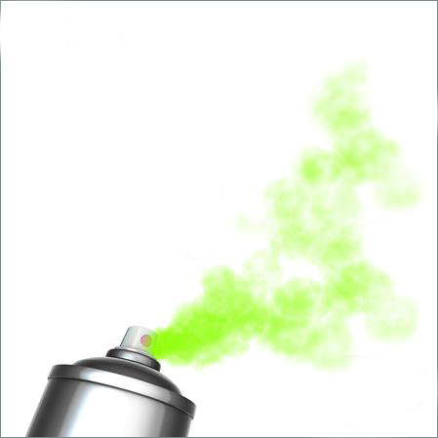
Teen Huffing/Inhalant Abuse refers to teens ingesting toxic products such as spray paints, cleaning products, glues, or other household products, in order to obtain a high. One of the great dangers of this kind of drug abuse is of course these substances are not meant to be ingested by humans in anyway, and therefore teens are putting themselves at great risk for unpredictable negative effects. Teen Huffing/Inhalant Abuse is usually done by younger teens.

Teen Huffing/Inhalant Abuse Symptoms
Teens may carry out huffing in different ways, in order to inhale the toxic substances. Teens may directly sniff a substance; sometimes, they’ll soak a rag with the chemical and inhale the fumes from it; and other times teens might spray the substance into their noses. Some of the most commonly abused substances include: glue, spray paint, gasoline, shoe polish, cleaning supplies, and other household products. Because the effect only lasts a few minutes, teens will often huff several times in repetition, in order to prolong their high. This of course makes teens even more vulnerable to adverse side effects of the chemicals.
The high that these substance produce is similar to that of alcohol, which is they depress the nervous system. More specifically, some of the symptoms teen huffing/inhaling abuse may have include: lack of inhibition, delusions, slurred speech, feelings of happiness and pleasure, drowsiness, tiredness, hallucinations, and dizziness. Some of the negative physical effects which huffing can cause include; irregular heartbeat, brain damage, hearing loss, vital organ damage, vomiting, nausea, and even death.

Teen Meth Abuse Treatment
Meth (or Methamphetamine) is an extremely addictive, strong stimulant drug that comes in an odorless, white powder form and is usually smoked, snorted, or injected. Meth causes a stimulating, euphoric high by affecting the central nervous system, and causing a rush of dopamine (a neurotransmitter that signals feelings of pleasure, among other things) to the brain.
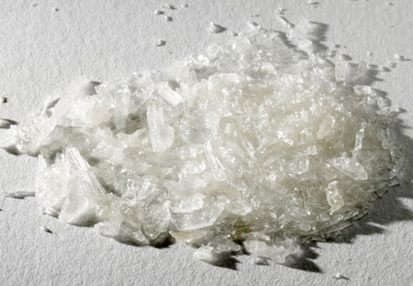

Teen Meth Abuse Symptoms
Meth is a stimulant and has effects similar to Cocaine or other stimulant drugs. Thus, Meth stimulates both the brain and body, and has effects such as: increased heart rate and blood pressure; increased energy; increased concentration; racing thoughts; insomnia; anxiety and/or agitation; aggressive/violent behavior; increased physical activity and restlessness; decreased appetite; and in some cases, psychotic symptoms such as delusions and/or paranoia. In some cases, teens may also experience symptoms such as nose-bleeds and severe dental problems, as prolonged meth abuse damages the mouth tissues. Meth can also cause teens to lose weight, and because of this is commonly present as a Co-Occurring disorder with a Teen Eating Disorder, such as Teen Anorexia or Teen Bulimia.
Beyond the physical symptoms which Teen Meth Abuse causes, there are also a number of negative effects to other areas of teens’ lives. Because teens become increasingly reliant upon the drug, they tend to become flaky and irresponsible with responsibilities such as school work and extracurricular activities. Therefore, it’s common for teens’ school performance to drop and/or be suspended or reprimanded regarding responsibilities. Beyond this, they may also withdraw from friends, suddenly change peer groups, and/or withdraw from others completely. Teen Meth Abuse also tends to cause tension in relationships between teens and their family members.

