Teen Acute Stress Disorder Treatment
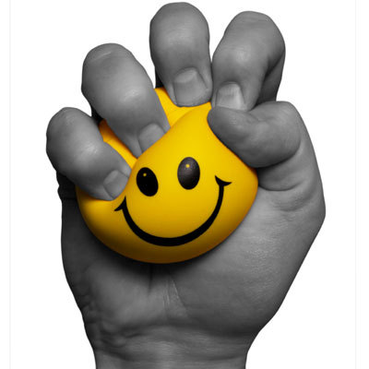
Description
Teen Acute Stress Disorder is an anxiety disorder, characterized by teens experiencing an extreme, overwhelming sense of fear, panic, and anxiety, which was triggered by a specific traumatic event. This condition is considered a precursor to Teen Post Traumatic Stress Disorder. The symptoms of the disorder can be so extreme that they prevent teens from being able to function healthily in their everyday lives.
Symptoms
Because the symptoms of Teen Acute Stress Disorder are directly related to the traumatic event which the teens experienced, they are closely related to the trauma. For instance, teens will often re-experience the events in sudden, overwhelming thoughts, in flashbacks, and in nightmares. Understandably, this persistent stress brought on by revisiting the traumatic event leads to considerable disruptions in the teens’ lives.
It’s very common for teens with Acute Stress Disorder to withdraw from others, as a way of hiding and/or protecting themselves from stimulation that might add to their stress. As a way of defending themselves against preventing any sort of traumatic event from occurring again in the future, the teens can become anxious and preoccupied about controlling their environment and experiences. This leads to strain on relationships and responsibilities, as well as leads to severe feelings of stress and anxiety.
Treatment
Teen Acute Stress Disorder Treatment often includes talk therapy and behavioral therapy approaches. In talk therapy sessions, our therapists work with teens to help them process the traumatic event and identify ways in which it’s currently affecting their experience. Because trauma can create a sort of “block”, which causes the anxious symptoms, therapists work with teens to identify what kinds of thought patterns have resulted from the trauma. Through this process, teens can gain relief from their anxiety as they start to express and release the stress from the trauma in more healthy, intentional ways. At the same time, as therapists work with teens to make these connections, they’ll also teach tools and resources that will help teens to reduce stress.

